
Committee on Research and Publications (CRP)
CRP.FORM.012 | SSHRC Explore Grant
SSHRC Explore Grants fund small-scale research projects to enable researchers to hire students at any level to participate in their research, thereby contributing to their professional development. This grant aims to encourage innovation, training, and mentoring initiatives for students under the supervision of faculty research which falls under SSHRC’s mandate.

If you have any questions about the policies and procedures for applying for an internal research grant, or the adjudication of the application, please refer to the policies and guidelines on-line or contact the Chair of the Committee on Research & Publications.

The Committee on Research & Publications is interdisciplinary. All members may not be familiar with the specialized language of different disciplines. Applicants are strongly encouraged to compose their applications with this in mind.

By submitting this application and in accordance with the Tri-Agency Guidance on the use of Artificial Intelligence in the development and review of research grant proposals, the applicant/s acknowledges that:
- Applicants are ultimately accountable for the complete contents of this application regardless of AI use. Privacy, confidentiality, data security, and the protection of intellectual property have to be prioritized in the development of grant applications.

If the applicant chose to use AI in the development of their application or plans to use it in the proposed research, the applicant may choose to disclose the AI tools and how they were/will be used. (max ½ page)

Please Note: The onus is on the applicant to ensure completion upon submission. Incomplete applications will not be adjudicated.

Name(s) of Applicant(s)  For eligibility, see CRP.SOP.002 | Click or tap here to enter text.
Department/Faculty | Click or tap here to enter text.
Title of Study | Click or tap here to enter text.
Total Amount Requested (Max $5,000) | $Click or tap here to enter text.

Insert Image of Researcher(s) Signature:   | Date: Click or tap to enter a date.

- Abstract or Summary – max ½ page
Click or tap here to enter text.

- Objectives and Context – max 2 pages
Click or tap here to enter text.
- Theoretical Framework and Methodology – max 1 page
Click or tap here to enter text.
- Originality, Significance, and Expected Outcomes – max ½ page
Click or tap here to enter text.
- References -- max 1 page
Click or tap here to enter text.
- Research Ethics Certification
Is ethics clearance required for this study?
☐ Yes
☐ No
- Knowledge Mobilization Plan– max ½ page
☐I agree to contact my Library Liaison to discuss open access or on-line publishers prior to committing funds to ensure the legitimacy of the publisher.
☐ I agree to acknowledge MSVU and SSHRC in any and all dissemination resulting from this grant.

Click or tap here to enter text.
- Future Funding – max ½ page
Click or tap here to enter text.
- Abbreviated C.V. – max 2 pages
Click or tap here to enter text.
- Outcomes from the Last Internal Grant
Have you been awarded an MSVU internal grant?
☐ No (please proceed to Section 10
☐ Yes (please complete the information below)

Date: Click or tap to enter a date.
Type: Choose an item.
Amount Awarded: $Click or tap here to enter text.
Please provide an overview of the outcomes from the final report submitted for the above-noted internal grant:
Click or tap here to enter text.

- Student Mentoring and Training – max 1 page
Click or tap here to enter text.

- Timeline – max ½ page
Click or tap here to enter text.
- Budget and Justification
The table below will expand to appear as an excel spreadsheet and will automatically calculate the total – double click to access the table (click outside of the spreadsheet when finished to exit back to the form)
Please note that at least half of the requested budget must be used to support student professional development, training, and mentoring.

Important Notice: For grants that are longer than one year, researchers must spend a minimum of 50% of their grant award in year one.

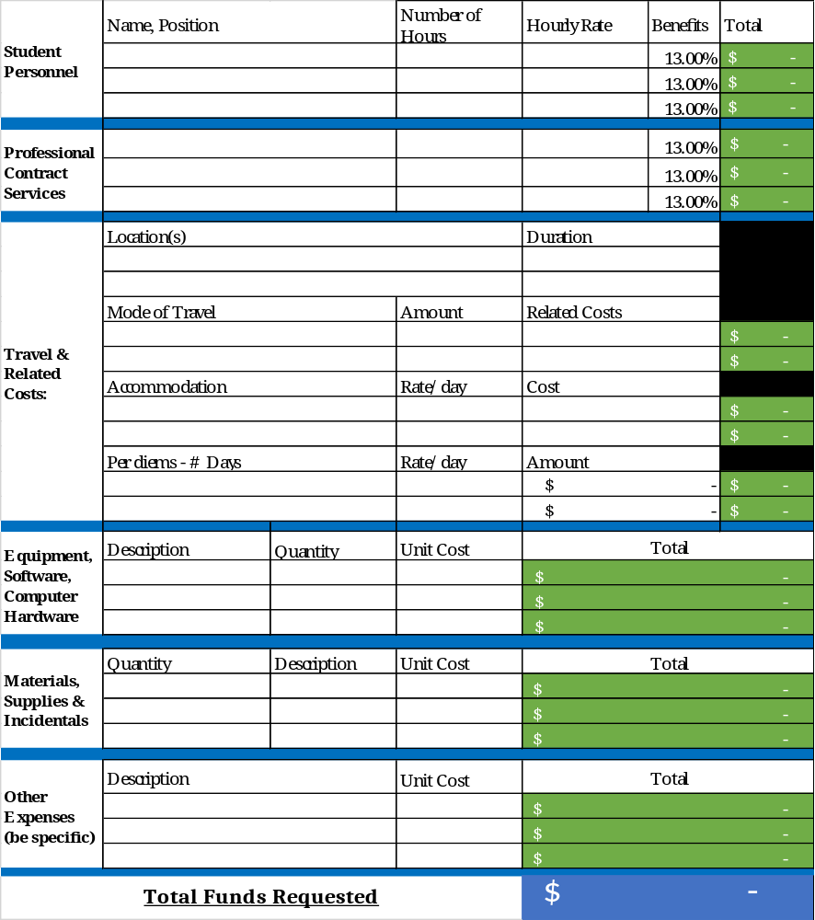

Budget Justification
Student Personnel
☐Not Applicable, or
Click or tap here to enter text.
Professional Contract Services/Personnel
☐Not Applicable, or
Click or tap here to enter text.
Travel & Related Costs
☐Not Applicable, or
Click or tap here to enter text.
Non-Disposable Equipment, Computer Hardware & Software
☐Not Applicable, or
Click or tap here to enter text.
Materials, Supplies & Incidentals
☐Not Applicable, or
Click or tap here to enter text.
Other Expenses
☐Not Applicable, or
Click or tap here to enter text.

Submission Process:
Please submit the application package electronically to research@msvu.ca

Note: a maximum of 2 attachments are permitted for submission– you may submit only .pdf or .doc(x) documents in the following manner:

- One attachment containing only the application and one document containing all appendices (if applicable)
or
- One attachment containing both the application and all appendices (if applicable)

All appendices must be clearly labeled and reflect how they are referenced in the application.

Equity, Diversity, Inclusion, and Accessibility
Dear Applicant: As you know, MSVU released its Senate approved 5-year Research Strategic Plan (2023-2028) in January 2023. Our research strategic plan, as well as our overarching institutional strategic plan, are foregrounded in the principles of Equity, Diversity, Inclusion and Accessibility (EDIA) and the Truth and Reconciliation recommendations. In addition, MSVU is now a member of the Dimensions program which is also aimed at advancing EDI. The MSVU Research Office is interested in understanding how our researchers are responding to these institutional priorities. The information you provide will help the Research Office offer the best possible support for meeting these institutional priorities.

MSVU Research Strategic Plan
Truth and Reconciliation
MSVU Dimensions Action Plan

As an MSVU researcher, we are inviting you to voluntarily answer the following questions. Your responses to these questions will not be used to determine the outcome of the grant adjudication process. Rather, the responses will be anonymized, used to provide additional supports such as training, and will be included in our annual report to Senate.

In the space provided below, please explain how your research proposal incorporates EDIA
(e.g., the inclusion of historically underrepresented populations on the research team).

☐ Not Applicable
In the space provided below, please explain how your research proposals incorporates one or more of the Truth and Reconciliation recommendations (e.g., considers Indigenous ways of knowing).

☐ Not Applicable
Our Senate-approved MSVU Research Strategic Plan includes 5 strategic research pillars. Please check the box beside the research pillar(s) that your research proposal involves (check all that apply)
☐ Pillar 1: Gender, Sexuality, and the Advancement of Women and Girls, and other Historically Underrepresented populations.
☐ Pillar 2: Intersectional Ways of Knowing and Knowledge Mobilization.
☐ Pillar 3: Health, Wellness and Social Justice Across the Life course.
☐ Pillar 4: Life, Computational, and Physical Sciences.
☐ Pillar 5: Supporting the Research Lifecycle. (e.g., access to infrastructure, promotion of best practices)

Thank you for your input!

