BIG PICTURE MAPPING
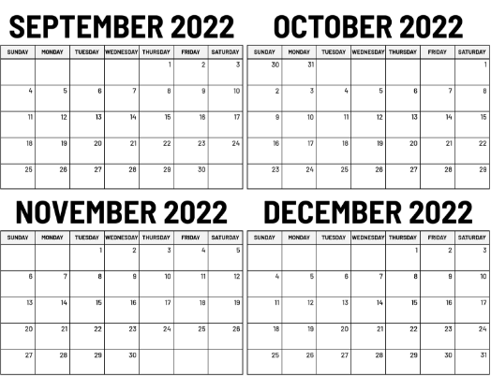
For each semester map out the next four months:
- DEADLINES: Find all the critical deadlines from each course outline (assignments, tests, presentations, etc) and add them to the Big Picture calendar.

- IMPORTANT DATES: Write down important university dates – start/end of classes, final exam period, course add/drop deadlines, etc.

- KEEP IT SIMPLE: Include just the key information – consider using an agenda/day planner for day-to-day task lists and assignment/test details.

- FREE TIME: Highlight times when there are no classes: e.g., Holidays, Reading Week, Winter Break, etc., seeing that a small break is coming may help with motivation to complete current tasks.

- FUN TIME: Write down important personal events that are happening during the semester, especially enjoyable activities that are part of your self-care.

- IN PLAIN SIGHT: Keep the Big Picture calendar in a place where you can see it and refer to it easily (such as a wall in your home study space).
Also consider:
- COLOUR-CODING: having each course a different colour, creating an additional visual cue.

- VALUES: including the value (% towards final grade) for each assignment/test/etc. can help with prioritizing tasks when there are multiple things due.

- DONE: cross/check off days/assignments when completed, this shows your progress (and it is very satisfying to cross something off our task lists!).
SAMPLE
