Committee on Research and Publications

CRP Standard Operating Guidelines and Procedures

DOC # | CRP.SOP.003
Title | Purpose and Envelopes of Funding
Document Type | Information
Effective Date | June 2021
Version | 6.0
Prev. Version | 5.0 June 2017
Next Review | 2024

Internal grants are divided into three streams: Research Grants, Research Dissemination and Special Calls, and Other Awards. MSVU faculty members are eligible to hold one grant or award from the first two streams (Research Grants and Research Dissemination and Special Calls) at a time. A graphic representation is below:
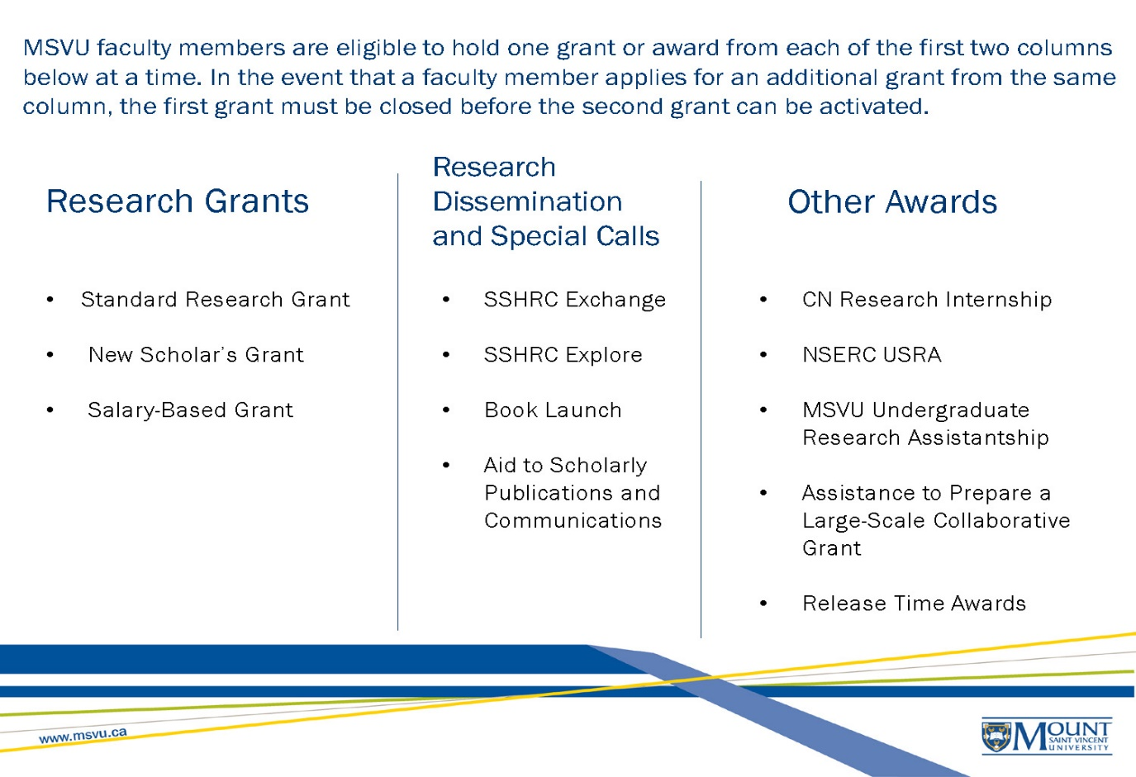

In the event that a faculty member applies for an additional grant from the same stream, the first grant must be closed before the second grant can be activated.
With the exception of the New Scholars Grant, internal grants are usually capped at budgets of $5,000 or less for two reasons:

- SSHRC policy specifies a maximum amount for internal funds;
- Compared with external grants, internal grant projects are normally of shorter term and or on a smaller scale.

Internal grants must be spent within the timeframe specified on the award. Possible extensions are only granted for exceptional circumstances, and are normally for a maximum of six months. Researchers must provide a rationale in writing to the to the Associate Vice-President (Research). Faculty members who have applied for external research grant funding are eligible to apply for internal funds to begin their research project before the decision from the external agency is received. Faculty who receive external awards that cover the proposed costs of the internal award are expected to return any unspent internal funds within one month of the award notification.
In the interest of promoting research, the Committee has created different envelopes of funding to which faculty members can direct their applications. They are described below.

Standard
- Standard Grants:
  - Provide seed money for pilot projects with potential for external grant applications,
  - Are used to support free-standing projects,
  - Fund new projects developing out of previously externally funded grant.
- The grant period is two years. The maximum amount awarded is $5,000.

Aid to Scholarly Publications and Communication
- Researchers can request funds to defray the final costs of publishing a peer-reviewed work such as a paper, book, or report. Such costs can include editing or indexing, or article processing charges Researchers can request funds for technical assistance with peer-reviewed papers, books or reports or costs associated with open access publishing. In addition, costs associated with non-print scholarly work, such as a media production, an exhibit or a performance may also be applied.
- The grant period is one year. The maximum amount awarded is $1,500.

Book Launches
- Researchers may request funds to defray costs associated with a book launch.
- The grant period is one year. The maximum amount awarded is $300.

Assistance to Prepare a Large Scale Grant Proposal
- Applications can be made to obtain assistance to prepare a large scale grant proposal (e.g., administrative or technical support, research team meetings, and application coordination).
- This category of activity implies that Mount faculty are working as a lead partner or in a major role in a large national or international collaborative effort.
- This category of activity does not include the more modest scale research grant competitions of SSHRC, NSERC, etc.
- The grant period is for one year. The maximum amount awarded is $2,500.

Salary-Based Grant
- Applicants whose proposal for a salary-based grant is approved will have their gross salary reduced by an amount corresponding to the total of the grant. The gross monthly amount of grant and salary (before deductions) may not exceed the normal gross monthly salary.

Note: It is incumbent on the grant recipient to contact MSVU Payroll Office to establish the grant as soon as notification of the award is received. For more information and general guidelines on salary-based grants, please refer to the Canada Revenue Agency Income Tax Folio (March 28, 2013) ~ S1-F2-C3: Scholarships, Research Grants and Other Education Assistance (http://www.cra-arc.gc.ca/tx/tchncl/ncmtx/fls/s1/f2/s1-f2-c3-eng.html)

Additional areas of funding:
- For detailed information on New Scholars Grants, please see CRP.SOP.009
- Special envelopes of funding are available in addition to those referenced above. Please see CRP.SOP.010 for details.
- In every case above, the application forms are available on the MSVU Research Office website.

